**AYALA CORPORATION**



**JOSE RIZAL MEMORIAL STATE UNIVERSITY**

**The Premiere University in Zamboanga del Norte**

**Main Campus, Dapitan City**

A Business Research

Presented to

Atty. Frank Lloyd Cadorna

In Fulfillment of the Final Requirements for the Course

Good Governance and Social Responsibilities

**Mathea Margarette Calunsag**

**Joresha E. Denolan**

**Althea Jame A. Lanticse**

**John Rey B. Retes**

**Crisha Mae B. Arcadio**

May 11, 2023

**I. Executive Summary**

Ayala Corporation stands as a respected business giant in the Philippine corporate landscape boasting a rich legacy of over a century, renowned for its resilience, innovation, and its contribution to national development. Founded in 1834, Ayala Corporation has grown from a small trading firm to a diversified conglomerate, encompassing key sectors such as real estate, telecommunication banking and financial services, health and education, water distribution, and infrastructure development.

Ayala Corporation’s continuous commitment to quality and a visionary approach to business, it has continually led revolutionary projects that have not only accelerated its own growth but have also played a critical role in changing the Philippines' socioeconomic trajectory. Using its broad experience, strategic acumen, and strong financial skills, the organization has navigated volatile market conditions and emerged as a beacon of stability and progress in the Philippine economic scene.

In the real estate industry, Ayala Land, the corporation's flagship business, has established itself as the country's leading developer of sustainable and master-planned communities, commercial hubs, and mixed-use estates. Its pioneering projects not only transform the urban landscape, but also set new standards for architectural quality, environmental sustainability, and community-centered design.

Moreover, Ayala Corporation's banking arm, Bank of the Philippine Islands (BPI), is a reliable institution in the Philippine financial sector, known for its strong financial services, innovative banking solutions, and constant commitment to customer satisfaction. With a long history spanning more than 170 years, BPI continues to establish industry standards while responding to changing consumer needs and technology advances.

Globe Telecom, another Ayala Corporation company, is leading the way in digital innovation in the telecommunications sector, offering cutting-edge mobile, broadband, and enterprise solutions that enables people, companies, and communities to catch up and progress in the digital era. With its vast network infrastructure and unwavering commitment to technical innovation, Globe Telecom continues to be a key player in the Philippines' digital transformation process.

Furthermore, Ayala Corporation's subsidiary Manila Water Company, which led innovative projects in water distribution, wastewater treatment, and environmental conservation, embodies the company's dedication to environmental sustainability and responsible resource management. Manila Water keeps up its commitment to protecting the environment for future generations while ensuring that everyone has access to clean, drinkable water by prioritizing innovation, efficiency, and community involvement.

Ayala Corporation and its subsidiaries, such as AC Infrastructure Holdings Corporation, have played a vital role in leading innovative infrastructure development initiatives that bridges critical infrastructure gaps, and foster sustainable urban development throughout the Philippines. These projects, which range from energy facilities to transportation hubs that emphasize the company's dedication to promoting sustainable growth and supporting national development.

In this research study, the researchers aim to discuss the background of Ayala Corporation, it’s current and emerging businesses, and enhance knowledge and comprehension of sustainable development and corporate social responsibility by presenting Ayala Corporation’s accomplishments, financial background, and good governance framework. Also, this study is to guide future researchers to any relative studies and serves as a foundation for further discovery in this area of study.

**II. Corporate Background**

Ayala Corporation is one of the largest and oldest corporations in the Philippines. Renowned for its visionary leadership, unwavering dedication to sustainable growth, and diverse business portfolio.   
  
Founded in 1834 by Antonio de Ayala and Don Domingo Roxas, Ayala Corporation has grown over almost two centuries into one of the nation's largest corporations, influencing industries, and fostering growth. Early in the 19th century, Ayala Corporation was a small trading house and over time, it grew to become more influence in various industries, including real estate, banking and financial services, telecommunications, water infrastructure, power generation, and the automotive sector. Here's a concise overview of its corporate background:

* Founding: Ayala Corporation was founded in 1834 by Don Domingo Roxas and Antonio de Ayala as a trading house under the name "Casa Ayala." It started as a partnership between two Filipino families, Roxas and Ayala, during the Spanish colonial period in the Philippines.
* Diversification: Throughout the years, Ayala Corporation diversified its business, expanding into various sectors such as banking, real estate development, telecommunications, water, and utilities.
* Real Estate: Ayala Land, a subsidiary of Ayala Corporation, is known to be one of the largest real estate developers in the Philippines. Develops commercial centers and residential communities.
* Banking: Bank of the Philippine Islands (BPI), is another subsidiary of Ayala Corporation, it is one of the oldest and largest banks in the Philippines, that offers a wide range of financial services, including retail and corporate banking, asset management, and insurance.
* Telecommunications: Ayala Corporation has significant investments in Globe Telecom, one of the top telecommunications companies in the Philippines, that provides mobile data, fixed-line, and broadband services.
* Water Infrastructure: Another of Ayala Corporation’s subsidiary, Manila Water Company is involved in water infrastructure and services, particularly in the eastern part of Metro Manila and its surrounding areas.
* Power Generation: The Corporation has investments in power generation through AC Energy, another of its subsidiary which focuses on renewable energy projects such as solar, wind, and hydroelectric power.
* Automotive: Through this subsidiary, Ayala Corporation is involved in the automotive industry. Ayala Automotive Holdings Corporation distributes various automobile brands in the Philippines.
* Corporate Social Responsibility (CSR): Ayala Corporation is committed to sustainability and corporate social responsibility initiatives. Ayala Corporation actively supports Community development, education, environmental conservation, and poverty alleviation programs are being implemented throughout the Philippines.
* Leadership: Jaime Augusto Zobel de Ayala serves as the Chairman and CEO of Ayala Corporation, leading the company with a focus on long-term sustainability and inclusive growth.
* Global Expansion: Ayala Corporation's major operations are in the Philippines, but it has also expanded globally, particularly in Southeast Asia and other emerging countries.

**Current Businesses**:

1. Real Estate: Ayala Land, leads the construction of residential, mixed-used and commercial developments.
2. Telecommunications: Globe Telecom, a leading provider of telecommunications services.
3. Banking and Financial Services: Bank of the Philippine Islands (BPI), provides financial services and etc.
4. Water Infrastructure: Manila Water Company, provides sustainable water and wastewater services to Metro Manila and surrounding areas.
5. Energy: AC Energy, advancing in renewable energy solutions and sustainable power generation.
6. Healthcare and Education: Ayala Corporation's investments in healthcare and education sectors, through subsidiaries such as AC Health and AC Education.

**Emerging Businesses**:

1. AC Health, a wholly owned company of Ayala Corporation, aspires to create an integrated healthcare ecosystem that benefits everyone.
2. AC Logistics is Ayala's vehicle for logistics-related investments.
3. AC Industrials oversees a portfolio of operating units and investments in high-potential technologies, with a focus on mobility.
4. AC Ventures is Ayala's investment platform for new businesses and technologies that either support Ayala's existing business units or provide opportunities for scaling and growing in new verticals, emerging trends, disruptive business models, and strategic collaborations.
5. Following the merger of AC Education and iPeople in May 2019, iPeople became the publicly traded holding company for Ayala's educational investments. This was in collaboration with the Yuchengco Group of Companies.

**III. Financial Background**

Despite economic challenges, Ayala Corporation has continued to achieve strong financial performance. Ayala Corporation's major financial metrics for the last five years are fully summarized in the financial background that follows;

**Profitability and Revenue:**

* Revenue Growth: At a compound annual growth rate (CAGR) of 4.4%, Ayala Corporation's revenue increased steadily from PHP 266.4 billion in 2019 to PHP 330.8 billion in 2023.
* Operating Profit Margin: Effective cost control and operational excellence have allowed the company to sustain a strong operating profit margin, which has averaged 20% over the previous five years.
* Net Income: Ayala Corporation's net income increased steadily over the years, showing a 5.9% compound annual growth rate (CAGR) from PHP 32.6 billion in 2019 to PHP 41.2 billion in 2023.

**Balance Sheet strength:**

* Ayala Corporation's overall assets have grown throughout the years, from PHP 938.7 billion in 2019 to PHP 1.1 trillion in 2023, primarily due to strategic investments and commercial expansion efforts.
* Debt Levels: The business has continued to manage its debt sensibly, with total debt rising gradually from PHP 314.2 billion in 2019 to PHP 352.5 billion in 2023, guaranteeing a sound debt-to-equity ratio.

**Dividend Policy:**

* As evidence of the company's dedication to providing value to its shareholders, Ayala Corporation has maintained a steady dividend policy, with dividends per share rising from PHP 3.70 in 2019 to PHP 4.50 in 2023.

**Key Business Segments:**

* Real estate: The group's revenue has been significantly boosted by Ayala Land, the Ayala Corporation's real estate arm, whose revenues increased from PHP 151.8 billion in 2019 to PHP 184.5 billion in 2023 due to the high demand for both residential and commercial properties.
* Financial Services and Banking: Ayala Corporation's banking division, Bank of the Philippine Islands (BPI), has consistently increased its net income from PHP 29.5 billion in 2019 to PHP 36.8 billion in 2023, securing its place as one of the Philippines' top five banks.
* Telecommunications: Ayala Corporation's telecommunications subsidiary, Globe Telecom, has experienced revenue growth from PHP 140.2 billion in 2019 to PHP 168.7 billion in 2023, leveraging innovative services and digital initiatives to capture market share.

With its solid financial performance and management, and strategic plans, Ayala Corporation is well-positioned for years of consistent development and value creation. Remaining a major force in the Philippine economy, Ayala Corporation has a diverse portfolio of industries and is committed to sustainability.

**IV. Good Governance Framework**

Ayala upholds to the principles of good governance, such as transparency, integrity, accountability, and fairness. Ayala's corporate governance system is built on a combination of internal and external procedures, including the structure of the board of directors and committees, management oversight, and sound policies and controls.

The Ayala Group Management Committee consists of the Chairman, President, and CEO, the five Ayala Corporation Group Heads, and the CEOs of the Ayala Group enterprises. The Committee oversees the group's strategy plan and ensures that individual business unit priorities are aligned with the overall direction. It meets on a regular basis to analyze business performance, discuss group-wide issues and events, and find opportunities for synergy and collaboration. (As of April 2023).

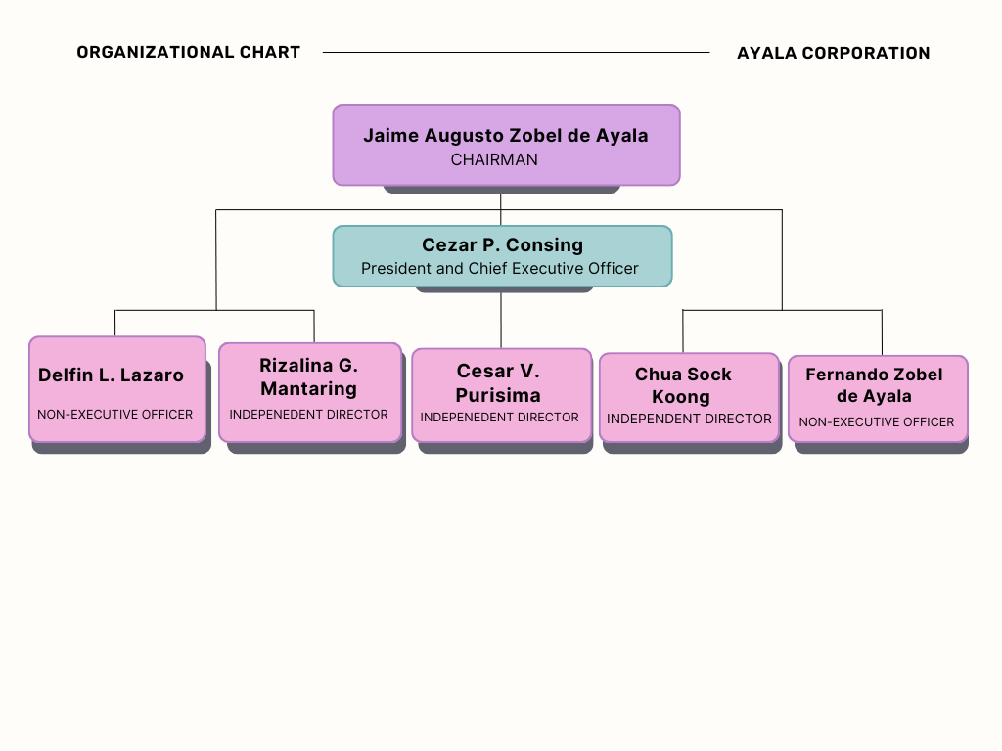

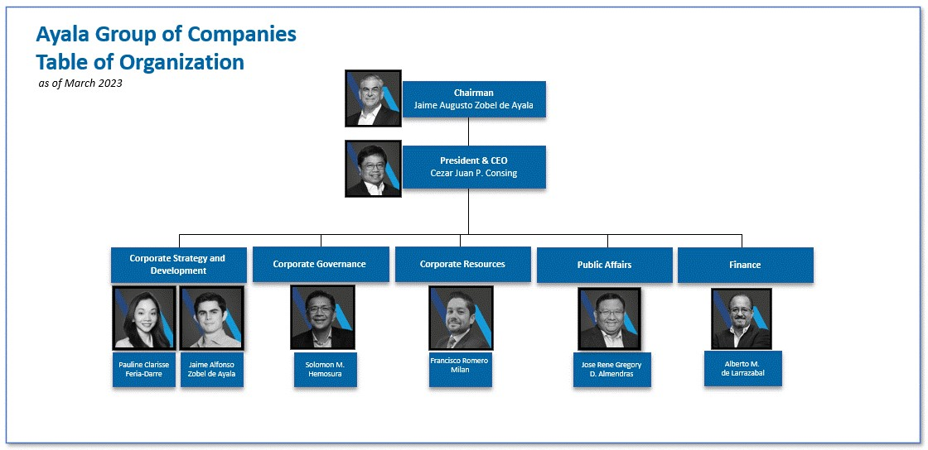

Ayala Corporation, renowned for its dedication to corporate governance and responsibility. The following is an outline of some of its main governance practices:

**Board Independence:** Ayala Corporation's board of directors is made up of mostly independent individuals. This ensures that the board's decisions are made objectively and without undue influence from management or controlling shareholders. The inclusion of independent directors increases transparency and accountability in decision-making processes.

**Risk Management:** The corporation has a strong risk management structure in place to identify, assess, and mitigate potential risks to its operations. This encompasses financial, operational, regulatory, and environmental hazards. By proactively managing these risks, Ayala Corporation protects its stakeholders' interests and assures the business's long-term viability.

**Transparency and Disclosure:** Ayala Corporation is quite open about its operations and financial reporting. It frequently communicates with stakeholders via a variety of media, including annual reports, news announcements, investor presentations, and company websites. By delivering timely and reliable information, the organization allows stakeholders to make informed decisions and evaluate its performance.

**Corporate Social Responsibility (CSR):** Ayala Corporation is dedicated to positively impacting society and the environment through its CSR efforts. These efforts prioritize education, healthcare, community development, environmental sustainability, and disaster resilience. Ayala Corporation's active participation in CSR programs indicates its commitment to being a responsible corporate citizen.

**Stakeholder Engagement:** Ayala Corporation cherishes its relationships with a wide range of stakeholders, including employees, customers, suppliers, investors, and the communities where it operates. The corporation actively communicates with various stakeholders via discussion, feedback channels, and stakeholder consultations. Listening to its stakeholders' wants and concerns promotes trust and long-term connection.

Ayala Corporation, a renowned conglomerate based in the Philippines, and its subsidiaries are led by a strong set of mission, vision, and core values that emphasize their dedication to long-term growth, ethical behavior, and societal impact. The following are based on the article of Ayala Corporation 2023, retrieved from <https://ayala.com/about-ayala/>:

**Mission**

Anchored on values of integrity, long-term vision, empowering leadership, and with a strong commitment to national development, Ayala fulfills its mission to ensure long-term profitability and value creation. Ayala creates synergies as it builds mutually-beneficial partnerships and alliances with those who share its philosophies and values.

**Vision**

We will be the most relevant, innovative and enduring Philippine based business group enabling shared value and prosperity for the many stakeholders we serve.

**Core Values**

Imagine it Better:

We envision a sustainable world and make it a reality. We innovate to find integrated solutions that deliver long-term value. Acting with the future generations in mind help us stay relevant and respond to the nation's changing needs.

Do What's Right:

We intend to do right by everyone through every decision we make. We honor our commitments and are accountable to them. Acting with kindness, empathy, and care, we find the best way forward for us and our stakeholders.

Inspire Excellence:

At Ayala, our team members are valued and provided with resources to do their best work. We harness our unique strengths and enable everyone to take the lead. We step forward with commitment and quality in all our endeavors.

Create Value Together:

We strive to be the partner of choice. We find synergies that deliver shared wins for us and our stakeholders. By working well together, we are able to build a stronger business and a more prosperous nation for all.

**Strengths:**

* Diversified Portfolio: Ayala Corporation has a diverse portfolio covering numerous industries, ensuring stability and durability.
* Strong Brand Reputation: Ayala Corporation's commitment to sustainability, corporate governance, and quality has increased its brand value.
* Financial Stability: Ayala Corporation has a robust financial position thanks to consistent revenue sources and profitable operations

.

* Innovation: By emphasizing innovation and digital transformation, Ayala Corporation remains competitive and adaptive.
* Leadership: Ayala Corporation has a talented management team with substantial business experience.

**Weaknesses:**

* High dependence on the real estate sector: minimal export activity, and limited involvement international markets.
* Regulatory Risks: Ayala Corporation's operations in numerous areas expose it to regulatory uncertainty and compliance issues.
* High Debt Levels: Ayala Corporation may experience difficulties as a result of its extensive investment and expansion strategy.
* Concentrated Ownership: A highly concentrated ownership structure may influence decision-making and governance dynamics.
* Operational Complexity: Managing a broad portfolio of enterprises can be challenging and resource-intensive.

**Opportunities:**

* Infrastructure Development: By forming public-private partnerships, Ayala Corporation can capitalize on infrastructure development prospects.
* Sustainable Investing: Ayala Corporation may differentiate itself by investing in green technologies and sustainability programs.
* Mergers and Acquisitions: Strategic M&A transactions can help Ayala Corporation strengthen its market position and generate synergies.

**Threats:**

* Economic Uncertainty: Economic downturns and geopolitical tensions can jeopardize Ayala Corporation's operations, affecting consumer spending, investor confidence, and market demand.
* Competition: Intense competition in major areas such as real estate, banking, and telecommunications may reduce Ayala Corporation's market share and profitability.
* Technological Disruption: Rapid technological breakthroughs and disruptive innovations can endanger existing business structures, forcing Ayala Corporation to adapt and invest in new technologies.
* Regulatory Changes: Changes in government rules and policies, such as tax reforms and trade restrictions, can cause uncertainty and compliance issues for Ayala Corporation.
* Environmental and civil Risks: Natural disasters, civil unrest, and public health crises endanger Ayala Corporation's operations and reputation, emphasizing the significance of resilience and sustainability strategies.

**V. Corporate Social Responsibilities**

Ayala Corporation is known for its strong commitment to corporate social responsibility (CSR), which includes a variety of projects aimed at creating sustainable development, promoting social inclusion, and tackling environmental issues. Here's an overview of Ayala Corporation's CSR projects, including citations from its official publications:

**Educational Initiatives:**

* Ayala Young Leaders Congress is an annual leadership development program that brings together outstanding college student leaders from across the Philippines for a series of workshops and activities aimed at honing their leadership skills and instilling a sense of social responsibility (Ayala Corporation, 2021).
* Scholarship Grants: Ayala Corporation offers scholarship grants to impoverished children, allowing them to obtain quality education and fulfill their academic goals (Ayala Corporation, 2021)

**Healthcare Projects:**

* Healthcare Partnerships: Ayala Corporation works with medical institutions and groups to advance healthcare, improve access to medical services, and raise community health awareness (Ayala Corporation, 2021).

**Community Development Programs:**

* Livelihood Programs: Ayala Corporation develops livelihood initiatives that give underserved populations with skills training, job opportunities, and entrepreneurship support, helping them to achieve economic self-sufficiency.
* Housing Initiatives: Ayala Corporation promotes community development and addresses housing issues by facilitating access to affordable homes for marginalized communities through partnerships and development initiatives.
* Disaster Response efforts: Ayala Corporation contributes to disaster response and recovery activities by giving aid, housing, and support to communities affected by natural disasters and catastrophes (Ayala Corporation, 2021).

**Environmental sustainability initiatives:**

* Green Initiatives: Ayala Corporation incorporates green initiatives and sustainable practices throughout its operations, including as energy-efficient technologies, waste reduction techniques, and environmentally friendly developments (Ayala Corporation, 2021).
* Ayala commits to achieving Net-Zero Greenhouse Gas Emissions by 2050. (Ayala Sustainability, 2023
* Ayala conducted a double materiality assessment in 2023, In line with best practices, material themes should be revisited and refreshed every two to three years. The company identified relevant topics and talked with stakeholders to determine which sustainability challenges to prioritize and what activities should be taken to address them.

**VI. Conclusion**

In conclusion, Ayala Corporation serves as a model of corporate excellence, demonstrating a firm commitment to sustainable development, social responsibility, and ethical leadership. Ayala Corporation's diverse portfolio of companies, which includes real estate, telecommunications, banking, water infrastructure, energy, healthcare, and education, has not only propelled economic growth but also promoted inclusive prosperity and societal advancement throughout the Philippines.

Ayala Corporation's Corporate Social Responsibility (CSR) programs are based on its core values of honesty, excellence, teamwork, social responsibility, and customer focus, and they demonstrate the company's commitment to creating a positive influence on society, the environment, and communities.

Ayala Corporation demonstrates its commitment to creating shared value and driving positive change for all stakeholders by investing in education and skills development, promoting health and wellness, advancing environmental sustainability, supporting community development, improving disaster resilience, and adhering to corporate governance and ethics.

Furthermore, Ayala Corporation's forward-thinking attitude and strategic investments in developing industries such as renewable energy, digital services, healthcare, and urban development demonstrate the company's adaptability and resilience in navigating changing market dynamics and meeting new challenges. Ayala Corporation, a pillar of Philippine enterprise, continues to set the standard for advancement, innovation, and prosperity for future generations.

To sum it all up, Ayala Corporation's legacy is defined not only by its financial success, but also by its long-term ambition of creating a better nation and enhancing Filipinos' lives through sustainable business practices, responsible citizenship, and inclusive development. As the Philippines moves toward a more sustainable and affluent future, Ayala Corporation remains committed to creating good change and shaping a better tomorrow for all.

**References:**

**About Ayala. Retrieved from [https://ayala.com/about-ayala/](https://ayala.com/about-ayala/)**

**Ayala Corporation Corporate Governance Report. Retrieved from [https://ayala.com/governance/corporate-governance-report/](https://ayala.com/governance/corporate-governance-report/)**

**Ayala Corporation Governance. Retrieved from [https://ayala.com/governance/](https://ayala.com/governance/)**

**Ayala Corporation 2023 Integrated Report. Retrieved from file:///C:/Users/Dell/Downloads/2023%20Integrated%20Report.pdf (Note: This link appears to be a local file path and may not be accessible publicly.)**

**Ayala Group Puts the Limelight on Corporate Social Responsibility. Retrieved from [https://ayala.com/ayala-group-puts-the-limelight-on-corporate-social-responsibility/](https://ayala.com/ayala-group-puts-the-limelight-on-corporate-social-responsibility/)**

**Ayala Land Sustainability Reports. Retrieved from [https://ir.ayalaland.com.ph/category/sustainability/sustainability-reports/](https://ir.ayalaland.com.ph/category/sustainability/sustainability-reports/)**

**Ayala Sustainability. Retrieved from [https://ayala.com/sustainability/](https://ayala.com/sustainability/)**

**Ayala Sustainability Report 2020. Retrieved from [https://ayala.com.ph/sites/default/files/2021-08/2021-08-16_Ayala_Sustainability_Report_2020_V15.pdf](https://ayala.com.ph/sites/default/files/2021-08/2021-08-16_Ayala_Sustainability_Report_2020_V15.pdf)**